2019 Youth Art Month Design Contest
Entries Due: November 30, 2018

GUIDELINES FOR ENTRY:
- Designs must be created by students of current AENJ members
- Designs must be submitted on 12” by 18” paper, horizontal format.
- Designs must include the YAM Theme (in bold lettering):
MADE IN NEW JERSEY
- DO NOT INCLUDE THE YAM LOGO IN THE DESIGN!
- Design must include the words: New Jersey or NJ
- Design must be a bold, 2-D, simple, flat-color design for reproduction.
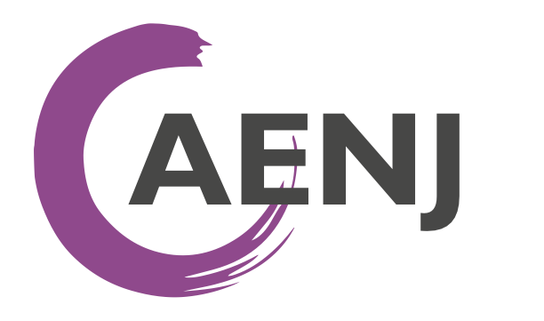
- No more than three (3) entries per school.
- Designs must be submitted no later than 11: 59 pm on November 30, 2018.
- NEW FOR 2019!!!! ART TEACHERS: Please submit all information provided on the permission slip
below AND the design file (picture) online, using the Google Form: https://goo.gl/nVoyDd

Celebrate Youth Art Month by participating in the YAM Design Contest! The Art Educators of New Jersey join other state art organizations to participate in the YAM Design Competition. Six winning entries will be chosen and used to celebrate Youth Art Month in New Jersey. One winning entry will be replicated on the state YAM flag and flown during the 2019 NAEA Conference in Boston. Other winning entries will be transformed into our state YAM poster, YAM button, YAM billboard, and two YAM invitations.

Sargent Art is providing student and teacher prizes! One overall student winner will receive a cash prize of $1,000 in the form of a check. The teacher of the overall student winner will receive classroom art supplies worth $1,200 (retail value).
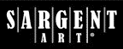
For each of the remaining five category winners listed above, each student winner will
receive art supplies worth $100 (retail value). The teacher of each student winner will
receive classroom art supplies worth $200 (retail value).

Sargent Art will also send a Participation Gift to each school. (*In order to receive a participation gift, the Principal of each participating school must e-mail the following information to Sargent Art: 1. School enrollment number; 2. Number of Art Teachers; and 3. Number of entries submitted to Youth Art Month.*). A form will be provided after your entry has been received.

The six winning entries will be displayed at the NJ State YAM Reception in Trenton on March 8, 2019.
SINCE WE ARE NOW GOING DIGITAL, ONLY WINNING ENTRIES WILL BE REQUESTED TO BE MAILED
For more information, please contact: AENJ NJ Youth Art Month Co-Chairs: Kristy Lopez and Karen Mannino at yam@aenj.org
---------------------------------------------------------------------------------------------------------------------------------------
2019 YAM Poster Design Contest Label/Release Form
(Art Teachers: Along with a picture of the image, please input this information into the Google Form: https://goo.gl/nVoyDd)

STUDENT NAME: __________________________________________ GRADE: ________ COUNTY: ________________________
ART TEACHER: ______________________________________ TEACHER’S EMAIL: _____________________________________
SCHOOL: __________________________________________________________ DISTRICT: ______________________________
SCHOOL ADDRESS: ________________________________ CITY: ________________________________ ZIP CODE: _________
I hereby grant permission for my child to participate in the 2019 YAM contest and exhibition, including publishing his/her work on the Web (ex: Artsonia.com) by AENJ. I understand that the Art Educators of NJ are not responsible or liable for any claims, damages, lost items/artwork, injuries and other liabilities of any kind that may arise from participation in this art exhibit. I also understand that AENJ reserves the right to refuse to include any work that does not follow the YAM Design Guidelines as stated above.

PARENT/GUARDIAN SIGNATURE: ____________________________________________________________________________
PARENT EMAIL: ___________________________________________________________ DATE: __________________________
STUDENT T-SHIRT SIZE: CHILD: S___ M___ L___ ADULT: S___ M___ L___ XL___ (PLEASE CHECK ONE)
NOTE: NOT ALL PARTICIPANTS WILL RECEIVE A FREE T-SHIRT. ONLY THE SIX DESIGN WINNERS WILL RECEIVE ONE.

