AENJ – EXHIBIT BACK LABEL
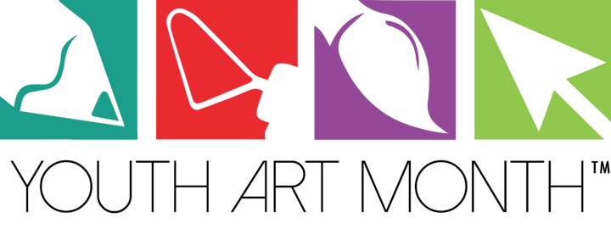
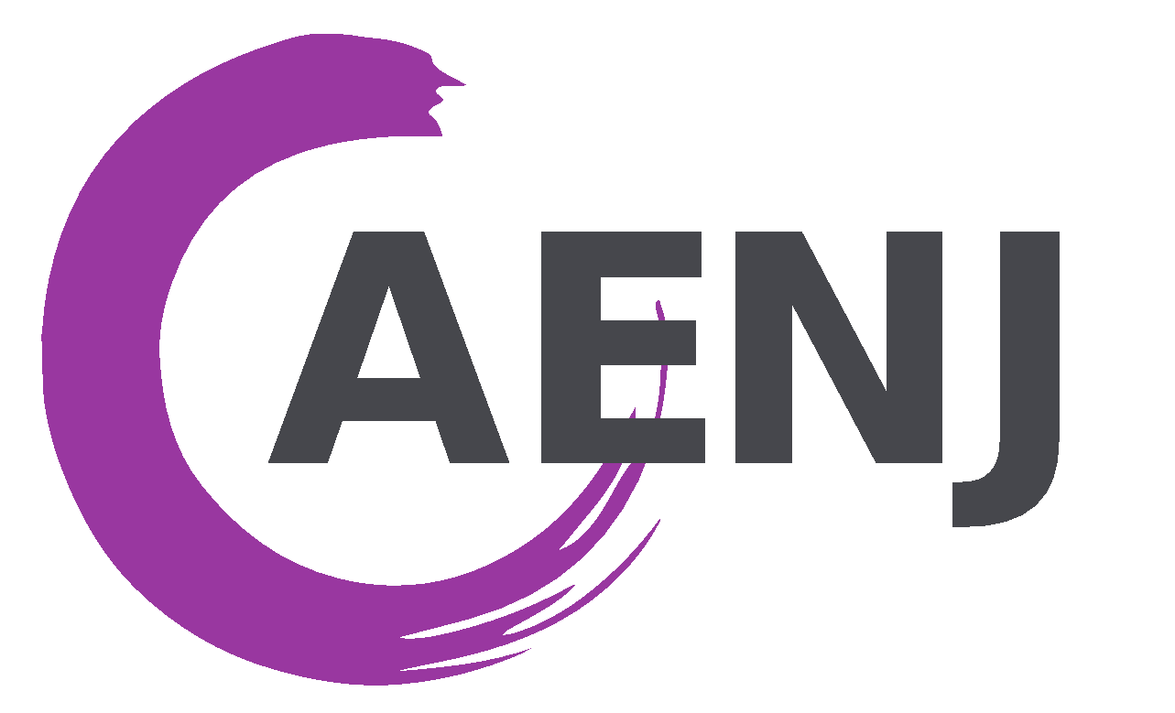
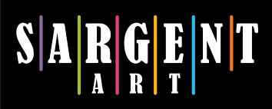

Dear Parents/Legal Guardians,

The purpose of this letter is to inform you that your child’s artwork has been selected to be exhibited in an art show sponsored by the Art Educators of New Jersey (AENJ), the professional organization for Art Teachers in NJ. AENJ is committed to protecting the privacy and safety of all students. With this in mind AENJ would also like to seek your permission to (1) exhibit the work and (2) possibly publish the work on the internet.

The artwork will be exhibited at NJ State YAM Exhibit – 125 West State Street, Trenton, NJ 08068 on March 9, 2018

With your permission the artwork may be published on the AENJ website at www.aenj.org & also on Artsonia - the largest children’s art museum on the internet at www.artsonia.com/aenj1. Understand that: (a)Artsonia preserves the student's privacy and anonymity by listing the artwork only under the student’s first name and a number; last names are not revealed; (b) AENJ & Artsonia do not require the student to relinquish his/her copyright; the student continues to own the copyright to his/her artwork; (c) Artsonia will only publish comments on student artwork with parental permission. Please see www.artsonia.com/terms.asp for details.

Answer questions 1, 2, & 3, fill out the form below then return it to your child’s art teacher.
1. _____YES, I do _____NO, I do not:
Give permission for my child’s artwork to be exhibited at: NJ State YAM Exhibit in Trenton – March 9, 2018

2. _____YES, I do _____NO, I do not:
Give permission for my child’s artwork to be published on the internet. I understand the student artwork will be identified by first name only, NO LAST NAME will be used.

3. Student T-Shirt Size (please check one): Child S___ M___ L___ Adult S___ M___ L___ XL___
Note: Not all art exhibits include a free t-shirt. Please check one size in case the exhibit your child is participating in requires this information.

I understand that the Art Educators of NJ are not responsible or liable for any claims, damages, lost items/artwork, injuries and other liabilities of any kind that may arise from participation in this art exhibit. I also understand that AENJ reserves the right to refuse to include any work improperly prepared to hang, work of the incorrect size or work received after the due dates set by AENJ.

Parent/Guardian Signature: ________________________________________________________ Date: ______________
Parent/Guardian Name (please print): ______________________________________________________________________
Student’s Name (please print): _________________________________________________________ Grade level: _______
Address: _____________________________________________________________________________________________
City: ___________________________________________________________ Zip Code: ____________________________
Phone number: ___________________________ Parent Email_________________________________________________

Art Teacher: ___________________________________________ E-mail address: _________________________________
School: ____________________________________________________________ County: __________________________
School Address: _______________________________________________________________________________________
City: __________________________________________________________ Zip Code: _____________________________
School District: ____________________________________ School Phone: _______________________________________

ALL EXHIBITING ART TEACHERS MUST BE MEMBERS OF AENJ!
Exhibits of student artwork are public events and photos of your child may be taken. These photos may be published in AENJ publications or used as promotional materials for the association. Names will not be used.
FOR AENJ USE ONLY

