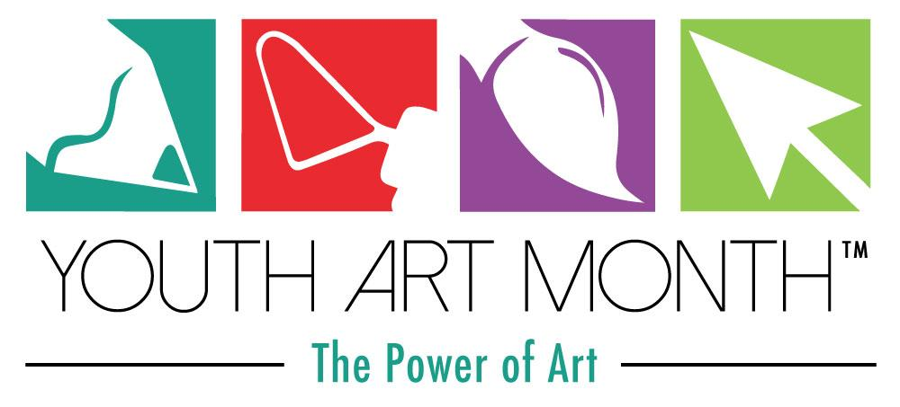
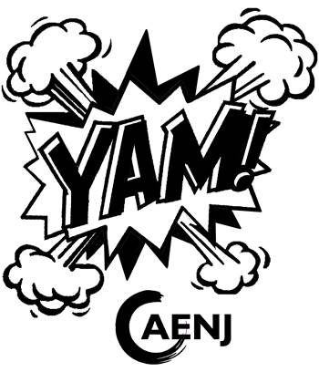

2018 YOUTH ART MONTH SPONSOR

I support the philosophy of Youth Art Month and I would like to become a sponsor for the 2018 New Jersey Youth Art Month. I understand that my sponsorship helps defray the costs of Youth Art Month. Attached is:

Platinum $100 ____ Gold $50 ____ Silver $25 ____ Bronze $10 ____ Other ____

Please make all checks payable to AENJ-YAM

I would not like my name to appear on any of the AENJ publications.

I would like my name to appear in Artbeat, the AENJ newsletter, and on the AENJ website.

Name as it should appear in publication: __________________________________________________________

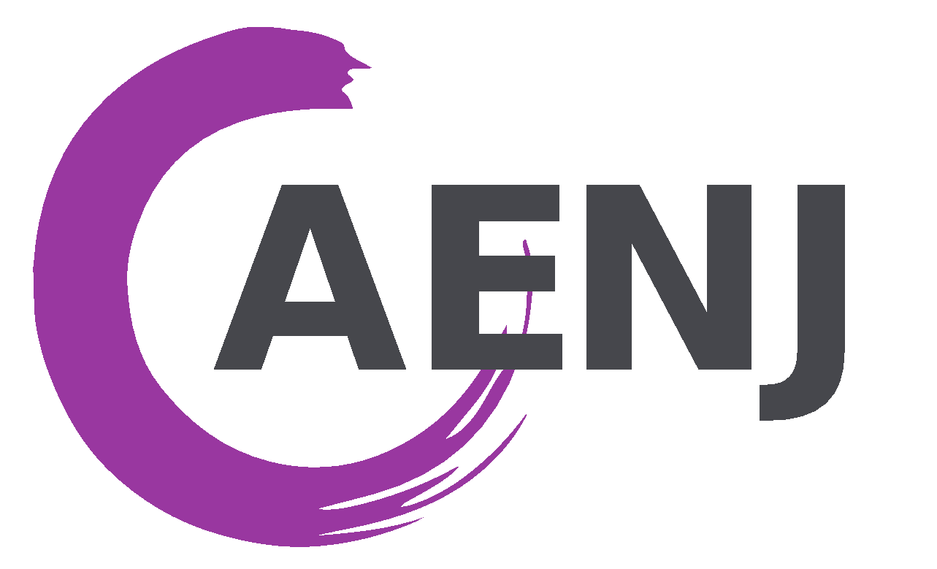
Given in honor of: __________________________________________________________________
Please mail this form and your check to:
Dr. Gene Neglia, Treasurer
c/o AENJ
2 Starboard Ct.
Brick, NJ 08723

The Art Educators of New Jersey thank you for your support of the visual arts and art education!

